CHAPTER-1
INTRODUCTION
1.1 Objective and goal of the thesis
With microprocessors getting faster every year, memory architectures must also improve to enhance overall system performance. The next generation of SDRAM is DDR, or Double Data Rate. Like SDRAM, DDR is synchronous with the system clock. Although similar, in that both are synchronous, the big difference between DDR and SDRAM is that DDR reads data on both the rising and falling edges of the clock signal, while SDRAM only carries information on the rising edge of a signal. This improvement allows the DDR module to transfer data twice as fast as SDRAM. As an example, instead of a data rate of 133MHz, DDR memory transfers data at 266MHz.
DDR modules, like their SDRAM predecessors, arrive in their. Although motherboards designed to implement DDR are similar to those that use SDRAM, they are not backward compatible with motherboards that support SDRAM. You cannot use DDR in earlier SDRAM based motherboards, nor can you use SDRAM on motherboards that are designed for DDR. DDR memory is available in either ECC (Error Correction Code) or non-ECC.

1.2 Random Access Memory
Random access memory (RAM) is the best known form of computer memory. RAM is considered "random access" because you can access any memory cell directly if you know the row and column that intersect at that cell. The opposite of RAM is serial access memory (SAM). SAM stores data as a series of memory cells that can only be accessed sequentially (like a cassette tape). If the data is not in the current location, each memory cell is checked until the needed data is found. SAM works very well for memory buffers, where the data is normally stored in the order in which it will be used (a good example is the texture buffer memory on a video card). RAM data, on the other hand, can be accessed in any order.

RAM is our working memory storage. All the data, which the PC uses and works with during operation, are stored here. Data are stored on drives, typically the hard drive. However, for the CPU to work with those data, they must be read into the working memory storage, which is made up of RAM chips.

1.2.1 Historical review
Back in the 80s, PCs were equipped with RAM in quantities of 64 KB, 256 KB, 512 KB and finally 1 MB. Think of a home computer like Commodore 64. It had 64 KB RAM, and it worked fine.
Around 1990, advanced operating systems, like Windows , appeared on the market, That started the RAM race. The PC needed more and more RAM. That worked fine with the 386 processor, which could address larger amount of RAM. The first Windows operated PCs could address 2 MB RAM, but 4 MB soon became the standard. The race has continued through the 90s, as RAM prices have dropped dramatically. Today. No one is using less than 32 MB RAM in a PC. Many have much more. 128 MB is in no way too much for a "power user" with Windows 95/98, it is important with plenty of RAM.

RAM Basics
Similar to a microprocessor, a memory chip is an integrated circuit (IC) made of millions of transistors and capacitors. In the most common form of computer memory, dynamic random access memory (DRAM), a transistor and a capacitor are paired to create a memory cell, which represents a single bit of data. The capacitor holds the bit of information -- a 0 or a 1 (see How Bits and Bytes Work for information on bits). The transistor acts as a switch that lets the control circuitry on the memory chip read the capacitor or change its state.
A capacitor is like a small bucket that is able to store electrons. To store a 1 in the memory cell, the bucket is filled with electrons. To store a 0, it is emptied. The problem with the capacitor's bucket is that it has a leak. In a matter of a few milliseconds a full bucket becomes empty. Therefore, for dynamic memory to work, either the CPU or the memory controller has to come along and recharge all of the capacitors holding a 1 before they discharge. To do this, the memory controller reads the memory and then writes it right back.
1.3 TYPES OF RAMS

1.3.1 FPM DRAM (Fast page mode DRAM)
Fast page mode dynamic random access memory was the original form of FPM RAM. It waits through the entire process of locating a bit of data by column and row and then reading the bit before it starts on the next bit. Maximum transfer rate to L2 cache is approximately 176 MBps. It offered faster access to data located within the same row.

1.3.2 EDO DRAM (Extended Data out DRAM)
Extended Data Out dynamic random access memory was the original form of EDO DRAM. Newer than DRAM (1995) and requires only one CPU wait state. EDO DRAM gave people up to 5% system performance increase over DRAM. EDO DRAM is like FPM DRAM with some cache built into the chip. Like FPM DRAM, EDO DRAM maxes out at about 50 MHz. EDO DRAM works along with L2 cache to make things even faster, but if you lose the L2 cache, you lose a lot of speed.
EDO DRAM does not wait for all of the processing of the first bit before continuing to the next one. As soon as the address of the first bit is located, EDO DRAM begins looking for the next bit. Maximum transfer rate to L2 cache is approximately 264 MBps.
1.3.3 Burst Extended Data out Dynamic random access memory
Burst Extended Data Out dynamic random access memory was the original form of BEDO DRAM. A step up from the EDO chips. It requires zero wait states and provides at least another 13 percent increase in performance.

Rambus dynamic Random access memory
Rambus dynamic random access memory was the original form of RDRAM. It is a radical departure from the previous DRAM architecture. Designed by Rambus, RDRAM uses a Rambus in-line memory module (RIMM), which is similar in size and pin configuration to a standard DIMM (Dual In-line Memory Modules). What makes RDRAM so different is its use of a special high-speed data bus called the Rambus channel. RDRAM memory chips work in parallel to achieve a data rate of 800 MHz, or 1,600 MBps.
Since they operate at such high speeds, they generate much more heat than other types of chips. To help dissipate the excess heat Rambus chips are fitted with a heat spreader, which looks like a long thin wafer. RDRAM has no CAS latency ratings, but may eventually come in 32 and 4 bank forms with 32-bank RDRAM costing more and performing better. For now, it's all 32-bank RDRAM.
1.3.5 Static Dynamic Random access memory
Static dynamic random access memory was the original form of SDRAM. Introduced in late 1996, retains memory and does not require refreshing. SDRAM is the replacement for DRAM, FPM, and EDO RAM types. It synchronizes itself with the timing of the CPU. It also takes advantage of interleaving and burst mode functions. SDRAM is faster and more expensive than DRAM. SDRAM initially shipped at a speed of 66 MHz. As memory buses got faster, it was pumped up to 100MHz, and then 133MHz.
SDRAM takes advantage of the burst mode concept to greatly improve performance. It does this by staying on the row containing the requested bit and moving rapidly through the columns, reading each bit as it goes. The idea is that most of the time the data needed by the CPU will be in sequence. SDRAM is about five percent faster than EDO RAM and is the most common form in desktops today. Maximum transfer rate to L2 cache is approximately 528 MBps.
SDRAM comes with latency ratings or "CAS (Column Address Strobe) latency" ratings. Standard PC100 / PC133 SDRAM comes in CAS 2 or CAS 3 speed ratings. The lower latency of CAS 2 memory will give you more performance. It also costs a bit more, but it's worth it.
SDRAM "locks" (synchronizes) the memory access to the CPU clock. This way we get faster data transfer. While one portion of data is transported to the CPU another can be being prepared for transfer.
SDRAM comes only in 64 bit modules (long 168 pin DIMMs). SDRAM has a access time of only 6-12 ns. The performance improvement over EDO RAM was 5 percent running at 66 MHz. At 100 and 133 MHz it proves better.

The advantage of SDRAM is increased speed. That allows you to increase system bus speed. With 60 ns EDO-RAM, you can run at a maximum of 75 MHz on the system bus, while SDRAM speed can increase to 133 MHz and above. Also the SDRAM work synchronous with the system bus for a better performance.

1.4 Double Data Rate Synchronous Dynamic random access memory
Double data rate synchronous dynamic random access memory was the original form of DDR SDRAM. It is just like SDRAM except that is has higher bandwidth, meaning greater speed. Maximum transfer rate to L2 cache is approximately 1,064 MBps (for DDR SDRAM 133 MHZ).
DDR RAM is clock doubled version of SDRAM, which is replacing SDRAM during 2001-2002. Allows transactions on both the rising and falling edges of the clock cycle. It has a bus clock speed of 100MHz and will yield an effective data transfer rate of 200MHz.
DDR comes in PC 1600, PC 2100, PC 2700 and PC 3200 DIMMs. A PC 1600 DIMM is made up of PC 200 DDR chips, while a PC 2100 DIMM is made up of PC 266 chips. PC 2700 uses PC 333 DDR chips and PC 3200 uses PC 400 chips that haven't gained widespread support. Go for PC2700 DDR. It is about the cost of PC2100 memory and will give you better performance. DDR memory comes in CAS 2 and CAS 2.5 ratings, with CAS 2 costing more and performing better.

1.4.1 PC 2100
Soon we shall see 266 MHz modules (being "overclocked"133 MHz SDRAM modules). The 266 MHz module reaches a 2.1 GB/sec bandwidth. Hence they are to be sold as PC2100 RAM. Other terms used are:
DDR200 (200 MHz)
DDR266 (266 MHz)
DDR333 (333 MHz)
1.4.2 Colum Address Strobe Latency
RDRAM has no CAS latency ratings, but may eventually come in 32 and 4 bank forms with 32-bank RDRAM costing more and performing better. For now, it's all 32-bank RDRAM.
SDRAM comes with latency ratings or "CAS (Column Address Strobe) latency" ratings. Standard PC100 / PC133 SDRAM comes in CAS 2 or CAS 3 speed ratings. The lower latency of CAS 2 memory will give you more performance. It also costs a bit more, but it's worth it.
DDR memory comes in CAS 2 and CAS 2.5 ratings, with CAS 2 costing more and performing better.
RAMBUS (RDRAM) is a more futuristic RAM type. Intel and others had great expectations from this type, but it flopped in 2000-2001.
1.4.3 RAMBUS RDRAM
RAMBUS RDRAM is extraordinarily fast. By using doubled clocked provides a transfer rate up to 1.6GBs yielding a 800MHz speed over a narrow 16 bit bus.
While the CPUs have become around 200 times faster in ten years, the RAM performance has only gone up 20 times. So we need new RAM types, many vendors decided to go for DDR RAM as described in. Where DDR RAM is a development of the existing SDRAM technology, Intel choose RDRAM, which represents a much more revolutionary change in RAM design. During 1999 and 2000, Rambus was not very successful. In fact, Intel has suffered a serious setback due to their commitment to the Rambus design.
RDRAM is developed from the traditional DRAM, but the architecture is completely new. It has been streamed and optimized to yield new performance. The RAMBUS design gives a more intelligent access to the RAM, meaning that units can "pre-fetch" data and this way free the CPU some work. The idea is that data is read in small packets at a very high clock speed. The Rambus modules work on 2.5 volts, which internally is reduced down to 0.5 volt when possible. This helps to reduce heat and radio signals.

1.5 Other Memory Types
1.5.1 Video RAM
VRAM is a video version of FPM and is most often used in video accelerator cards. Because it has two ports, It provides the extra benefit over DRAM of being able to execute simultaneous read/write operations at the same time.
One channel is used to refresh the screen and the other manages image changes. VRAM tends to be more expensive. Video RAM, also known as multi port dynamic random access memory (MPDRAM), is a type of RAM used specifically for video adapters or 3-D accelerators. The "multi port" part comes from the fact that VRAM normally has two independent access ports instead of one, allowing the CPU and graphics processor to access the RAM simultaneously. VRAM is located on the graphics card and comes in a variety of formats, many of which are proprietary.
The amount of VRAM is a determining factor in the resolution and color depth of the display. VRAM is also used to hold graphics-specific information such as 3-D geometry data and texture maps. True multi port VRAM tends to be expensive, so today, many graphics cards use SGRAM (synchronous graphics RAM) instead. Performance is nearly the same, but SGRAM is cheaper.

1.5.2 Flash Memory
This is a solid-state, nonvolatile, re-writable memory that functions like RAM and a hard disk combined. If power is lost, all data remains in memory. Because of its high speed, durability, and low voltage requirements, it is ideal for digital cameras, cell phones, printers, handheld computers, pagers and audio recorders.
1.5.3 Shadow RAM
When your computer starts up (boots), minimal instructions for performing the startup procedures and video controls are stored in ROM (Read Only Memory) in what is commonly called BIOS. ROM executes slowly. Shadow RAM allows for the capability of moving selected parts of the BIOS code from ROM to the faster RAM memory.

1.5.4 SRAM
Static RAM uses a completely different technology. In static RAM, a form of flip-flop holds each bit of memory. A flip-flop for a memory cell takes four or six transistors along with some wiring, but never has to be refreshed. This makes static RAM significantly faster than dynamic RAM. However, because it has more parts, a static memory cell takes up a lot more space on a chip than a dynamic memory cell. Therefore, you get less memory per chip.
Static random access memory uses multiple transistors, typically four to six, for each memory cell but doesn't have a capacitor in each cell. It is used primarily for cache. So static RAM is fast and expensive, and dynamic RAM is less expensive and slower. So static RAM is used to create the CPU's speed-sensitive cache, while dynamic RAM forms the larger system RAM space.

Cache RAM
This is where SRAM is used for storing information required by the CPU. It is in kilobyte sizes of 128KB, 256KB, etc.

DRAM
Dynamic random access memory has memory cells with a paired transistor and capacitor requiring constant refreshing. DRAM works by sending a charge through the appropriate column (CAS) to activate the transistor at each bit in the column. When writing, the row lines contain the state the capacitor should take on. When reading, the sense-amplifier determines the level of charge in the capacitor. If it is more than 50 percent, it reads it as a 1; otherwise it reads it as a 0. The counter tracks the refresh sequence based on which rows have been accessed in what order. The length of time necessary to do all this is so short that it is expressed in nanoseconds.
A memory chip rating of 70ns means that it takes 70 nanoseconds to completely read and recharge each cell. One of the most common types of computer memory (RAM). It can only hold data for a short period of time and must be refreshed periodically. DRAMs are measured by storage capability and access time. Storage is rated in megabytes (8 MB, 16 MB, etc). Access time is rated in nanoseconds (60ns, 70ns, 80ns, etc) and represents the amount of time to save or return information. With a 60ns DRAM, it would require 60 billionths of a second to save or return information. The lower the nano speed, the faster the memory operates. DRAM chips require two CPU wait states for each execution. Can only execute either a read or write operation at one time. The capacitor in a dynamic RAM memory cell is like a leaky bucket. It needs to be refreshed periodically or it will discharge to 0. This refresh operation is where dynamic RAM gets its name.

Dynamic RAM has to be dynamically refreshed all of the time or it forgets what it is holding. The downside of all of this refreshing is that it takes time and slows down the memory.
Memory cells are etched onto a silicon wafer in an array of columns (bit lines) and rows (word lines). The intersection of a bit line and word line constitutes the address of the memory cell. Memory cells alone would be worthless without some way to get information in and out of them. So the memory cells have a whole support infrastructure of other specialized circuits. These circuits perform functions such as:
Memory is made up of bits arranged in a two-dimensional grid. In this figure, red cells represent 1s and white cells represent 0s. In the animation, a column is selected and then rows are charged to write data into the specific column.
Identifying each row and column (row address select and column address select) Keeping track of the refresh sequence (counter) Reading and restoring the signal from a cell (sense amplifier) Telling a cell whether it should take a charge or not (write enable) Other functions of the memory controller include a series of tasks that include identifying the type, speed and amount of memory and checking for errors. The traditional RAM type is DRAM (dynamic RAM). The other type is SRAM (static RAM). SRAM continues to remember its content, while DRAM must be refreshed every few milli seconds.
DRAM consists of micro capacitors, while SRAM consists of off/on switches. Therefore, SRAM can respond much faster than DRAM. SRAM can be made with a rise time as short as 4 ns.
DRAM is by far the cheapest to build. Newer and faster DRAM types are developed continuously. Currently, there are at least four types:
FPM (Fast Page Mode)
ECC (Error Correcting Code)
EDO (Extended Data Output)
SDRAM (Synchronous Dynamic RAM)

1.5.7 DRAM types
FPM was the traditional RAM for PCs, before the EDO was introduced. It is mounted in SIMM modules of 2, 4, 8, 16, or 32 MB. Typically, it is found in 60 ns or 70 ns versions. 60 ns is the fastest and the one to use. You cannot mix different speeds on the same Pentium motherboard.
EDO (Extended Data Out) RAM is an improvement of FPM RAM. Data are read faster. EDO extends the time that output data is valid, which betters timing issues between the CPU and RAM and this way improves the performance.
By switching from FPM to EDO, one could expect a performance improvement of 2 to 5 percent. EDO RAM was usually sold in 60 ns versions. A 50 ns version was available at higher cost. EDO has now been replaced by the even faster SDRAM. ECC RAM is a special error correcting RAM type. It is especially used in servers.

1.6 Memory Modules
Memory chips in desktop computers originally used a pin configuration called dual inline package (DIP). This pin configuration could be soldered into holes on the computer's motherboard or plugged into a socket that was soldered on the motherboard. This method worked fine when computers typically operated on a couple of megabytes or less of RAM, but as the need for memory grew, the number of chips needing space on the motherboard increased.
The solution was to place the memory chips, along with all of the support components, on a separate printed circuit board (PCB) that could then be plugged into a special connector (memory bank) on the motherboard. Most of these chips use a small outline J-lead (SOJ) pin configuration, but quite a few manufacturers use the thin small outline package (TSOP) configuration as well. The key difference between these newer pin types and the original DIP configuration is that SOJ and TSOP chips are surface-mounted to the PCB. In other words, the pins are soldered directly to the surface of the board, not inserted in holes or sockets. Memory chips are normally only available as part of a card called a module. You've probably seen memory listed as 8x32 or 4x16.
These numbers represent the number of the chips multiplied by the capacity of each individual chip, which is measured in megabits (Mb), or one million bits. Take the result and divide it by eight to get the number of megabytes on that module. For example, 4x32 means that the module has four 32-megabit chips. Multiply 4 by 32 and you get 128 megabits. Since we know that a byte has 8 bits, we need to divide our result of 128 by 8. Our result is 16 megabytes.
The type of board and connector used for RAM in desktop computers has evolved over the past few years. The first types were proprietary, meaning that different computer manufacturers developed memory boards that would only work with their specific systems. Then came SIMM, which stands for single in-line memory module. This memory board used a 30-pin connector and was about 3.5 x 0.75 inches in size (about 9 x 2 cm). In most computers, you had to install SIMMs in pairs of equal capacity and speed. This is because the width of the bus is more than a single SIMM. For example, you would install two 8-megabyte (MB) SIMMs to get 16 megabytes total RAM. Each SIMM could send 8 bits of data at one time, while the system bus could handle 16 bits at a time.
Later SIMM boards, slightly larger at 4.25 x 1 inch (about 11 x 2.5 cm), used a 72-pin connector for increased bandwidth and allowed for up to 256 MB of RAM. As processors grew in speed and bandwidth capability, the industry adopted a new standard in dual in-line memory module (DIMM).
With a whopping 168-pin or 184-pin connector and a size of 5.4 x 1 inch (about 14 x 2.5 cm), DIMMs range in capacity from 8 MB to 1 GB per module and can be installed singly instead of in pairs. Most PC memory modules and the modules for the Mac G5 systems operate at 2.5 volts, while older Mac G4 systems typically use 3.3 volts. Another standard, Rambus in-line memory module (RIMM), is comparable in size and pin configuration to DIMM but uses a special memory bus to greatly increase speed.
Many brands of notebook computers use proprietary memory modules, but several manufacturers use RAM based on the small outline dual in-line memory module (SODIMM) configuration. SODIMM cards are small, about 2 x 1 inch (5 x 2.5 cm), have 144 or 200 pins. Capacity ranges from 16 MB to 1 GB per module. To conserve space, the Apple iMac desktop computer uses SODIMMs instead of the traditional DIMMs. Sub-notebook computers use even smaller DIMMs, known as MicroDIMMs, which have either 144 pins or 172 pins.

1.6.1 Cache Memory
Cache Memory is fast memory that serves as a buffer between the processor and main memory. The cache holds data that was recently used by the processor and saves a trip all the way back to slower main memory. The memory structure of PCs is often thought of as just main memory, but it's really a five or six level structure:
The first two levels of memory are contained in the processor itself, consisting of the processor's small internal memory, or registers, and L1 cache, which is the first level of cache, usually contained in the processor.
The third level of memory is the L2 cache, usually contained on the motherboard. However, the Celeron chip from Intel actually contains 128K of L2 cache within the form factor of the chip. More and more chip makers are planning to put this cache on board the processor itself. The benefit is that it will then run at the same speed as the processor, and cost less to put on the chip than to set up a bus and logic externally from the processor.
The fourth level is being referred to as L3 cache. This cache used to be the L2 cache on the motherboard, but now that some processors include L1 and L2 cache on the chip, it becomes L3 cache. Usually, it runs slower than the processor, but faster than main memory.
The fifth level (or fourth if you have no "L3 cache") of memory is the main memory itself. The sixth level is a piece of the hard disk used by the Operating System, usually called virtual memory. Most operating systems use this when they run out of main memory, but some use it in other ways as well.
This six-tiered structure is designed to efficiently speed data to the processor when it needs it, and also to allow the operating system to function when levels of main memory are low. If there were one type of super-fast, super-cheap memory, it could theoretically satisfy the needs of this entire memory architecture. This will probably never happen since you don't need very much cache memory to drastically improve performance, and there will always be a faster, more expensive alternative to the current form of main memory.
1.7. Memory Types
In order to enable computers to work faster, there are several types of memory available today. Within a single computer there is no longer just one type of memory. Because the types of memory relate to speed, it is important to understand the differences when comparing the components of a computer.
1.7.1 SIMM (Single In-line Memory Modules)
SIMMs is used to store a single row of DRAM, EDO or BEDO chips where the module is soldered onto a PCB. One SIMM can contain several chips. When you add more memory to a computer, most likely you are adding a SIMM.
The first SIMMs transferred 8 bits of data at a time and contained 30 pins. When CPU's began to read 32-bit chunks, a wider SIMM was developed and contained 72 pins. 72 pin SIMMs are 3/4" longer than 30 pin SIMMs and have a notch in the lower middle of the PCB. 72 pin SIMMs install at a slight angle.
SIMMs were first made in 8 bit editions. They were small cards with 1, 2 or 4 MB RAM. They were connected to the motherboard with a 30 pin edge connector. The modules were 8 bit wide. This meant that 16 bit processors (286 and 386SX) needed 2 SIMMs in a pair. Thus, there was room for two modules in what is called a bank.
1.7.2 DIMM (Dual In-line Memory Modules)
The most used modern RAM type, SDRAM is made in 64 bit wide modules called DIMMs (Dual Inline Memory Module). They have a 168 pin edge connector. Since the DIMM modules are 64 bits wide, you can install one module at a time. They are available in 8, 16, 32, 64, 128, 256 MB, and 512MB with 6, 8, 10, and 12 ns speed. There are usually 2-4 DIMM sockets on a motherboard. DIMMs allow the ability to have two rows of DRAM, EDO or BEDO chips. They are able to contain twice as much memory on the same size circuit board. DIMMs contain 168 pins and transfer data in 64 bit chunks. DIMMs install straight up and down and have two notches on the bottom of the PCB.
    - SODIMM (Small Outline DIMM)
SODIMMs are commonly used in notebooks and are smaller than normal DIMMs. There are two types of SODIMMs. Either 72 pins and a transfer rate of 32 bits or 144 pins with a transfer rate of 64 bits.

RIMM
The RIMMs hold controlling chips that turns off the power to sections not in use. They can also reduce the memory speed if thermal sensors report of overheating. The RIMM modules hold 184 pins.
The RIMM modules are only 16 bit wide compared to the traditional 64 bit SDRAM DIMMs, but they work at a much higher clock frequency.

1.7.3.2 CRIMMs
All RAM slots have to be full; this is new, with RAMBUS we have to fill in blank modules in slots which are not in use. The blank modules are called CRIMMs (with a 'C' for continuity).
1.7.4 RDRAM - RIMM
The RDRAM chips have to be placed very close to the CPU to reduce radio noise. This indicates, that RIMM technology is rather sensitive.
Rambus, Inc, in conjunction with Intel has created new technology, Direct RDRAM, to increase the access speed for memory. RIMMs appeared on motherboards sometime during 1999. The in-line memory modules are called RIMMs. They have 184 pins and provide 1.6 GB per second of peak bandwidth in 16 bit chunks. As chip speed gets faster, so does the access to memory and the amount of heat produced. An aluminum sheath, called a heat spreader, covers the module to protect the chips from overheating.

1.7.5 CMOS RAM
CMOS RAM is a term for the small amount of memory used by your computer and some other devices to remember things like hard disk settings for details. This memory uses a small battery to provide it with the power it needs to maintain the memory contents.
It becomes complicated to describe the relationship between RAM speed and the ability of the system bus to utilize fast RAM. But here is a table which illustrates RAM speed, relative to clock speed.

1.8. Different speeds supported by RAM

1.8.1 RAM speeds
RAM speed is measured in ns (nano seconds). The fewer ns, the faster is the RAM. Years ago, RAM came in 120, 100 and 80 ns. Today, we are talking about 60 ns and faster.
Clock speed Time per clock tick
20 MHz 50 ns
25 MHz 40 ns
33 MHz 30 ns
50 MHz 20 ns
66 MHz 15 ns
100 MHz 10 ns (supported)
133 MHz 6 ns

1.8.2 High clock rates
As mentioned, the modules are only 16 bit wide, but they work at 600, 700 and 800 MHz. Actually a PC800 RIMM runs on a 400 MHz clock using both rising and falling edges, being clock doubled just as
DDR RAM. More confusing the PC600 RIMM actually runs on a 266/532 MHz clock, and the

PC700 works at 366/712 MHz.
PC800 800/400 MHz
PC700 712/366 MHz
PC600 532/266 MHz

This gives the bandwidth of up to 1.6 GB per second, compared to the 500-800 MB/sec of PC100 SDRAM of a single Rambus channel.

1.9 Comparing bandwidth
Below you see the theoretical band width of different RAM types. The CPU and other units cannot read the data at these speeds; they have to wait some clock cycles in between each reading before the data transfers start. The same goes for DDR RAM.
RAM type Theoretical max. bandwidth
SDRAM 100 MHz 100 MHz X 64 bit= 800 MB/sec
SDRAM 133 MHz 133 MHz X 64 bit= 1064 MB/sec
DDRAM 200 MHz (PC1600) 2 X 100 MHz X 64 bit= 1600 MB/sec
DDRAM 266 MHz (PC2100) 2 X 133 MHz X 64 bit= 2128 MB/sec
DDRAM 366 MHz (PC2600) 2 X 166 MHz X 64 bit= 2656 MB/sec
RDRAM 600 MHz 600 MHz X 16 bit= 1200 MB/sec
RDRAM 700 MHz 700 MHz X 16 bit= 1400 MB/sec
RDRAM 800 MHz 800 MHz X 16 bit= 1600 MB/sec

1.10 Memory Redundancy
One important aspect to consider in memory is what level of redundancy you want. There are a few different levels of redundancy available in memory. Depending on your motherboard, it may support all or some of these types of memory:
The cheapest and most prevalent level of redundancy is non-parity memory. When you have non-parity memory in your machine and it encounters a memory error, the operating system will have no way of knowing and will most likely crash, but could corrupt data as well with no way of telling the OS. This is the most common type of memory, and unless specified, that's what you're getting.
The second level of redundancy is parity memory (also called true parity). Parity memory has extra chips that act as parity chips. Thus, the chip will be able to detect when a memory error has occurred and signal the operating system.
The third level of redundancy is ECC (Error Checking and Correcting). This requires even more logic and is usually more expensive. Not only does it detect memory errors, but it also corrects 1-bit ECC errors. If you have a 2-bit error, you will still have some problems. Some motherboards enable you to have ECC memory.

CHAPTER-2

DDR SDRAM CONTROLLER CORE
2.1 Introduction
For illustration purposes, the DDR SDRAM (1Meg x 2 x 4 banks) is chosen for this design. This design has been verified using Modelsim simulation model. It is highly recommended to download the simulation model from the DDR vendor for timing simulation.
Synchronous DRAM (SDRAM) has become a mainstream memory of choice in design due to its speed, burst access and pipeline features. For high-end applications using processors, the interface to the SDRAM is supported by the processor’s built-in peripheral module. However, for other applications, the system designer must design a controller to provide proper commands for SDRAM initialization, read/write accesses and memory refresh. This SDRAM controller reference design, located between the SDRAM and the bus master, reduces the user’s effort to deal with the SDRAM command interface by providing a simple generic system interface to the bus master.
Figure 1 shows the relationship of the controller between the bus master and SDRAM. The bus master can be either a microprocessor or a user’s proprietary module interface.
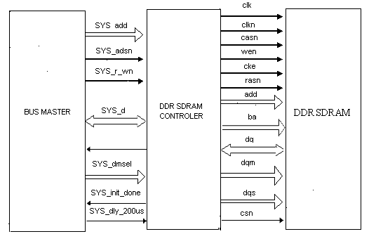

Fig.1 SDR SDRAM Controller System
2.2. SDRAM Overview
SDRAM is high-speed Dynamic Random Access Memory (DRAM) with a synchronous interface. The synchronous interface and fully pipelined internal architecture of SDRAM allows extremely fast data rates if used efficiently. SDRAM is organized in banks of memory addressed by row and column. The number of row and column address bits and number of banks depends on the size of the memory.

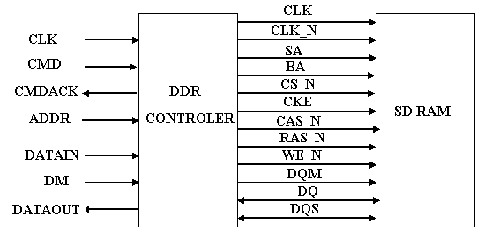

Figure.2 DDR SDRAM Controller System Level

SDRAM is controlled by bus commands that are formed using combinations of the RASN, CASN, and WEN signals. For instance, on a clock cycle where all three signals are high, the associated command is a No Operation (NOP). A NOP is also indicated when the chip select is not asserted. The standard SDRAM bus commands are shown in Table.1
SDRAM banks must be opened before a range of addresses can be written to or read from. The row and bank to be opened are registered coincident with the Active (ACT) command. When a bank is accessed for a read or a write it may be necessary to close the bank and re-open it if the row to be accessed is different than the row that is currently opened. Closing a bank is done with the Pre charge (PCH) command.
The primary commands used to access SDRAM are Read (RD) and Write (WR). When the WR command is issued, the initial column address and data word is registered. When a RD command is issued, the initial address is registered. The initial data appears on the data bus 1-3 clock cycles later. This is known as CAS latency (CL) and is due to the time required to physically read the internal DRAM core and register the data on the bus. The CAS latency depends on the speed of the SDRAM and the frequency of the memory clock.
Command | RAS | CAS | WE
No Operation (NOP) | L | L | L
Active(ACT) | H | L | L
Read(RD) | L | H | L
Write(WR) | L | H | H
Pre-charge(PCH) | H | L | H
Auto Refresh(ARF) | H | H | L
Load Mode Register(LMR) | H | H | H

Table.1 Controller Bus Commands
In general, the faster the clock, the more cycles of CAS latency required. After the initial RD or WR command, sequential read and writes will continue until the burst length is reached or a Burst Terminate (BT) command is issued. DDR SDRAM memory devices support burst lengths (BL) of 2,4, or 8 data cycles. DDR devices double the data rate by clocking data in and out of the device on every clock edge. The Auto Refresh command (ARF) is issued periodically to insure data retention. This function is performed by the SDRAM Controller and is transparent to the user.
The Load Mode Register command (LMR) is used to configure the SDRAM mode register. This register stores the CAS latency, burst length, burst type, and write burst mode.
SDRAM come in Dual In-line Memory Modules (DIMM) and as chips. To reduce pin count SDRAM row and column addresses are multiplexed onto the same pins. SDRAM often includes more than one bank of memory internally and may DIMMS may require multiple chip selects.

2.3. Controller Description
The Double Data Rate (DDR) Synchronous Dynamic Random Access Memory (SDRAM) Controller provides a simplified interface to industry standard DDR SDRAM memory. The SDRAM controller reference design is available in Verilog. The DDR SDRAM controller supports the following features:
- SDRAM burst lengths of 2,4, or 8.
- CAS latency of 1.5, 2.0, 2.5, or 3.0.
- 16 bit programmable refresh counter used for automatic refresh.
- Support for 2 banks of SDRAM devices.
- Supports the following commands: NOP, READA, WRITEA, AUTO_REFRESH, PRECHARGE, ACTIVATE and LOAD_MR.
- Data Mask lines are supported for write operations.
- Supports SDRAM data path widths of 16, 32, and 64 bits.
- Utilizes two PLL’s to increase system performance.
- Provides a peak performance of 1.6Gbytes/s with a system clock of 100 MHz and a 64-bit.
- Simplifies SDRAM command interface to standard system read/write interface. Internal state machine built for SDRAM power-on initialization.
- Read/write cycle access time optimized automatically according to the SDRAM timing spec and the mode it’s configured to.
- Dedicated auto-refresh request input and acknowledge output for SDRAM refresh.
- Easily configurable to support different CAS latency and burst length.
- Differential clock inputs (CK and CK#)
- Commands entered on each positive CK edge
- DQS edge-aligned with data for READs; centeraligned with data for WRITE..
- DLL to align DQ and DQS transitions with CK Four internal banks for concurrent operation
2.4 Functional Description:

The DDR SDRAM uses double data rate architecture to achieve high-speed operation. The double data rate architecture is essentially a 2n-prefetch architecture with an interface designed to transfer two data words per clock cycle at the I/O pins. A single read or write access for the DDR SDRAM effectively consists of a single 2n-bit wide, one-clock cycle data transfer at the internal DRAM core and two corresponding n-bit wide, one half- clock- cycle data transfers at the I/O pins.
A bidirectional data strobe (DQS) is transmitted externally, along with data, for use in data capture at the receiver. DQS is a strobe transmitted by the DDR SDRAM during READs and by the memory controller during WRITEs. DQS is edge-aligned with data for READs and center-aligned with data for WRITEs. The x16 offering has two data strobes, one for the lower byte and one for the upper byte.
The DDR SDRAM operates from a differential clock (CK and CK#); the crossing of CK going HIGH and CK# going LOW will be referred to as the positive edge of CK. Commands (address and control signals) are registered at every positive edge of CK. Input data is registered on both edges of DQS, and output data is referenced to both edges of DQS, as well as to both edges of CK. Read and write accesses to the DDR SDRAM are burst oriented; accesses start at a selected location and continue for a programmed number of locations in a programmed sequence. Accesses begin with the registration of an ACTIVE command, which may then be followed by a READ or WRITE command. The address bits registered coincident with the ACTIVE command are used to select the bank and row to be accessed. The address bits registered coincident with the READ or WRITE command are used to select the bank and the starting column location for the burst access.
The DDR SDRAM provides for programmable READ or WRITE burst lengths of 2, 4, or 8 locations. An AUTO PRECHARGE function may be enabled to provide a self-timed row precharge that is initiated at the end of the burst access. As with standard SDR SDRAMs, the pipelined, multi bank architecture of DDR SDRAMs allows for concurrent operation, thereby providing high effective bandwidth by hiding row precharge and activation time.
An auto refresh mode is provided, along with a power-saving power-down mode. All inputs are compatible with the JEDEC standard for SSTL_2. All full-drive option outputs are SSTL_2, Class II compatible.
The functional block diagram of the SDRAM controller is shown in Figure 2. It consists of three modules: the main control module, the signal generation module and the data path module. The main control module, containing two state machines and a counter, is the primary module of the design which generates proper iState and cState outputs according to the system interface control signals. The signal generation module generates the address and command signals required for SDRAM based on iState and cState. The data path module performs the data latching and dispatching of the data between the bus master and SDRAM.
The isp MACH 5000VG reference design illustrates the use of the sys_CLOCK PLL and sysIO features. All modules derive internal timing from the ispMACH 5000VG’s PLL clock output. This PLL clock also outputs through a dedicated ispMACH 5000VG pin (PLL_OUT0 or PLL_OUT1) and can be connected to the SDRAM directly. A separate onboard SDRAM clock may not be required. With the ispMACH 5000VG sysIO feature, the bus master I/O can be LVCMOS1.8/2.5/3.3, LVTTL, PCI, PCI-X or GTL+. The sysCLOCK PLL and sysIO are also supported by the Lattice, LatticeECP/EC and ispXPLD device families.
When targeting to other Lattice CPLD devices, instead of generating SDRAM clock with the CPLD, the system needs an on-board clock source such as a clock oscillator to generate the clocks for both the CPLD and the SDRAM.

Pin Name | Pin Type |  |  |  |  |  | Pin Description
Sys_R_Wn | ln |  |  |  |  |  | System interface read/write signal. High indiacates a write cycle.  When this pin is high, it indicates to the controller that the bus master is performing a read cycle. When low, it indicates that it’s a write cycle.
Sys_ADSn | ln |  |  |  |  |  | Active low system interface address strobe. This pin indicates the fstart master cycle.
Sys_DLY_100US | ln |  |  |  |  |  | This active high indicates to the controller that the SDRAM has gone through the 100us delay for power and clock stabilization
Sys_CK | ln |  |  |  |  |  | System interface clock.
Sys_RESET | ln |  |  |  |  |  | This active high signal resets the controller to the initial state.
Sys_REF_REQ | Ln |  |  |  |  |  | Active high SDRAM refresh request.
Sys_REF_ACK | Out |  |  |  |  |  | Active high SDRAM refresh acknowledge.
Sys_A | ln |  |  |  |  |  | System interface address bus.
Sys_D | In/Out |  |  |  |  |  | Bi-directional three-state system interface data bus.
Sys_D_VALID |  | Out |  |  |  |  | Active high data valid signal. This pin actives only for read cycles and indicates the data currently present on the system interface data bus sys_D is valid
Sys_CYS_END |  | Out |  |  |  |  | This active high signal indicates to the bus master that the system interface read/write cycle is completed. This pin is active after reset. After that, it is negated at the first clock and asserted at the last clock of the system interfaces read/write cycle.
Sys_INIT_DONE |  | Out |  |  |  |  | This active high signal indicates that the SDRAM initialization is completed.
Sdr_DQ |  | In/out |  |  |  |  | SDRAM data bus.
Sdr_A |  | Out |  |  |  |  | SDRAM address.
Sdr_BA |  | Out |  |  |  |  | SDRAM bank address.
Sdr_CKE |  | Out |  |  |  |  | SDRAM clock (if PLL is used,this will be the PLL output pin PLL_OUT0 or PLL_OUT)
Sdr_CSn |  |  | Out |  |  | SDRAM clock enable
Sdr_RASn |  |  | Out | SDRAM command inputs CS#
Sdr_CASn |  |  | Out | SDRAM command inputs RAS#
Sdr_Wen |  |  | Out | SDRAM command inputs CAS#
Sdr_Dem |  |  | Out |  | SDRAM data bus mask

Table.2 Pin Description

BLOCK DIAGRAM

:
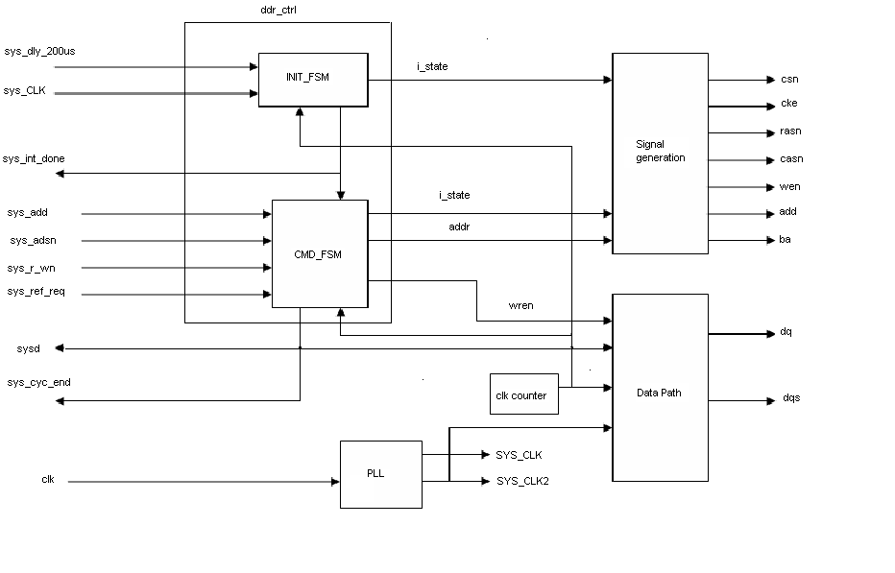

Fig.3. Controller Block Diagram

2.5 Controller Interface Signals
Signal | Name | Active | I/O | Description
CLK | Clock | NA | Input | System Clock
RESET_N | Reset | LOW | Input | System Reset
ADDR[ASIZE-1-0] | Memory Address | NA | Input | Memory address for read/write request. Width is set by ASIZE
CMD[2:0] | Command | NA | Input | Command request
CMDACK | Command Acknowledge | High | Output | Acknowledge of the requested command
DATAIN[DSIZE-1:0] | Input data | NA | Input | Input data bus. Width is set by DSIZE.
DATAOUT[DSIZE-1:0] | Output data | NA | Output | Output data bus. Width is set by DSIZE.
DM[(DSIZE/8)-1:0] | Data Mask | HIGH | Input | Makes individual bytes during data writes

Table.3 User Interface to the SDRAM controller

The DDR SDRAM Controller interface signals are shown in Table 4. Interface Signals. All signals are synchronous to the system clock and outputs are registered at the output of the SDRAM Controller Core.

Signal | Name | Active | I/O | Description
SCLK | Clock | NA | Input | System Clock.
SCLK_N | Clock | NA | Input | Inverted System Clock.
SA[11:0] | Address Bus | NA | Output | SA[11:0] is sampled during the ACT command to latch the row address. SA[n:] is sampled during the RD/WR command to latch the column address where n depends on the size of SDRAM command to determine if all bank selected by BA[1:0],the address outputs also provide the op-code during the CMR command
BA[1:0] | Bank Address | NA | Output | These signals determined to witch bank the ACT,RD, WR, or PCH command being applied.
CSW_N[1:0] | Chip Selects | LOW | Output | SDRAM chip selects.
CKE | Clock Enable | HIGH | Output | SDRAMCKE input.
RAS_N | Row Address Strobe | LOW | Output | SDRAM Command input
CAS_N | Column Address Strobe | LOW | Output | SDRAM Command input
WE_N | Write Enable | LOW | Output | SDRAM Command input
DQ[Dsize/2-1:0] | Data Mask | High | Output | SDRAM Data Mask individual bytes during data write.
DQS[DSIZE/2-1:0] | Data Strobe | NA | Output | SDRAM Data strobe, strobe data into the DDR devices during a write operation.

Table.4 SDRAM controller interface with DDR SDRAM

2.6 Controller Command Interface
The DDR SDRAM Controller provides a synchronous command interface to the DRAM along with several control registers. The commands are listed in Table.3 with detailed descriptions in following sections. Commands are issued to the controller as follows:
- A command, other than NOP, is driven, by the user, onto CMD[2:0] with ADDR and DATAIN set appropriately for the requested command. The controller registers the command on the next rising clock edge.
- To acknowledge the command the controller will assert CMDACK for one clock period.
- If the command was READA or WRITEA, the user will need to start receiving or0writing data on the DATAOUT and DATAIN ports. Refer to the READA and WRITEA timing diagram for more detail.
- The user must drive NOP onto CMD[2:0] by the next rising edge of CLK after
CMDACK has been asserted.

command | Value | Description
NOP | 000b | No Operation.
READ | 001b | SDRAM Read with Auto precharge.
WRITE | 010b | SDRAM Write with Auto precharge.
REFRESH | 011b | SDRAM Auto refresh.
PRECHARGE0 | 100b | SDRAM precharge all banks.
LOAD_MODE | 101b | SDRAM Load Mode Register.
LOAD_REG1 | 110b | Load controller configuration register.
LOAD_REG2 | 111b | Load controller refresh period register.

Table.5 Interface Commands

2.7 DDR SDRAM Initialization:
2.7.1 Initiate FSM
Before normal memory accesses can be performed, the SDRAM needs to be initialized by a sequence of commands. The INIT_FSM state machine handles this initialization. Figure 3 shows the state diagram of the INIT_FSM state machine. During reset, the INIT_FSM is forced to the i_NOP state. After reset, the sys_100 is signal will be sampled at the rising edge of every PLL clock cycle to determine if the 100 is power/clock stabilization delay is completed. After the power/clock stabilization is complete, the SDRAM initialization sequence will begin and the INIT_FSM will switch from i_NOP to i_PRE state.
The initialization starts with the PRECHARGE command, followed by two AUTO REFRESH commands, and then the LOAD MODE REGISTER command to configure SDRAM to a specific mode of operation. The i_PRE, i_AR1, i_AR2 and i_MRS states are used for issuing these commands. After each of these commands is issued, a corresponding timing delay needs to be satisfied before any command other than NOP can be issued.
These timing delays are tRP, tRFC and tMRD for command PRECHARGE, AUTO REFRESH and LOAD MODE REGISTER respectively. After issuing the LOAD MODE REGISTER command andthe tMRD timing delay is satisfied, INIT_FSM goes to i_ready state and remains there for the normal memory access cycles unless sys_RESET is asserted. Also, signal sys_INIT_DONE is set to high to indicate the SDRAM initialization is completed.
The LOAD MODE REGISTER command configures the SDRAM by loading data into the mode register through the address bus. The data present on the address bus during the LOAD MODE REGISTER command is loaded to the mode register. The mode register contents specify the burst length, burst type, CAS latency, etc. Refer to the SDRAM vendor’s data sheet for more detailed information about the mode register field definitions.
As long as all banks of the SDRAM are put into idle state by the PRECHARGE or AUTO PRECHARGE, the mode register can be reloaded with different values, thereby changing the mode of operation. However, in most applications, the mode register value will not be changed after the initialization. This design assumes the mode register stays the same after initialization and fixed mode register content is implemented in the HDL code. The mode register content in the HDL code may need to be modified to suit the user’s needs.

As mentioned above, certain timing delays (tRP, tRFC, tMRD) need to be satisfied before another non-NOP command can be issued. These SDRAM delays vary from speed grade to speed grade and sometimes from vendor to vendor.To accommodate this without sacrificing performance, the designer needs to modify the HDL code for the specific delays and clock period (tCK). According to these timing values, the number of clocks the state machine will stay at i_tRP, i_tRFC1, i_tRFC2, i_tMRD states will be determined after the code is synthesized. In cases where tCK is larger than the timing delay, the state machine doesn’t need to switch to the timing delay states and can go directly to the command states. The dashed lines in Figure 3 show the possible state switching paths.

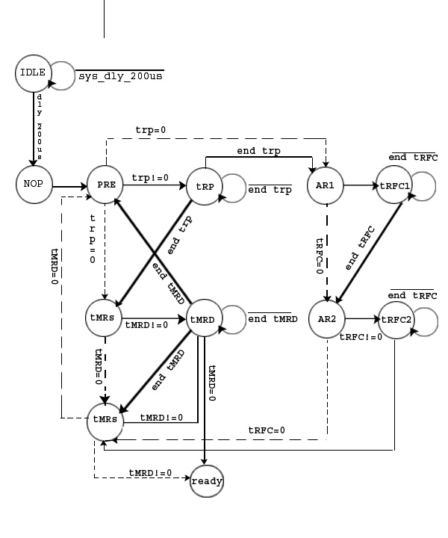
Fig.4 INIT_FSM State Diagram

2.7.2 INITIALIZATION Operations:
Prior to normal operation, DDRSDRAMs must be powered up and initialized in a predefined manner. Operational procedures, other than those specified, may result in undefined operation.
To ensure device operation, the DRAM must be initialized as described in the following steps:
- Simultaneously apply power to VDD and VDDQ.
- Apply VREF and then VTT power. VTT must be applied after VDDQ to avoid device latch up, which may cause permanent damage to the device. Except for CKE, inputs are not recognized as valid until after VREF Is applied.
- Assert and hold CKE at LVCMOS logic LOW. Maintaining an LVCMOS LOW level on CKE during power-up is required to ensure that the DQ and DQS outputs will be in the High-Z state, where they will remain until driven in normal peration (by a read access).
- Provide stable clock signals.
- Wait at least 100µs.
- Bring CKE HIGH, and provide at least one NOP or DESELECT command. At this point, the CKE input changes from a LVCMOS input to a SSTL_2 input only and will remain a SSTL_2 input unless a power cycle occurs.
- Perform a PRECHARGE ALL command.
- Wait at least tRP time; during this time NOPs or DESELECT commands must be given.
- Using the LMR command, program the extended mode register (E0 = 0 to enable the DLL and E1 = 0 for normal drive; or E1 = 1 for reduced drive and E2–En must be set to 0 [where n = most significant bit]).
- Wait at least tMRD time; only NOPs or DESELECT commands are allowed.
- Using the LMR command, program the mode register to set operating parameters and to reset the DLL. At least 200 clock cycles are required between a DLL reset and any READ command.
- Wait at least tMRD time; only NOPs or DESELECT commands are allowed.
- Issue a PRECHARGE ALL command.
- Wait at least tRP time; only NOPs or DESELECT commands are allowed.
- Issue an AUTO REFRESH command. This may be moved prior to step 13.
- Wait at least tRFC time; only NOPs or DESELECT commands are allowed.
- Issue an AUTO REFRESH command. This may be moved prior to step 13.
- Wait at least tRFC time; only NOPs or DESELECT commands are allowed.
- Although not required by the Micron device, JEDEC requires an LMR command to clear the DLL bit (set M8 = 0). If an LMR command is issued, the same operating parameters should be utilized as in step 11.
- Wait at least tMRD time; only NOPs or DESELECT commands are allowed.
- At this point the DRAM is ready for any valid command. At least 200 clock cycles with CKE HIGH are required between step 11 (DLL RESET) and any READ command.

2.7.3 Command FSM
Similar to the FP and EDO DRAM, row address and column address are required to pinpoint the memory cell location of the SDRAM access. Since SDRAM is composed of four banks, bank address needs to be provided as well.

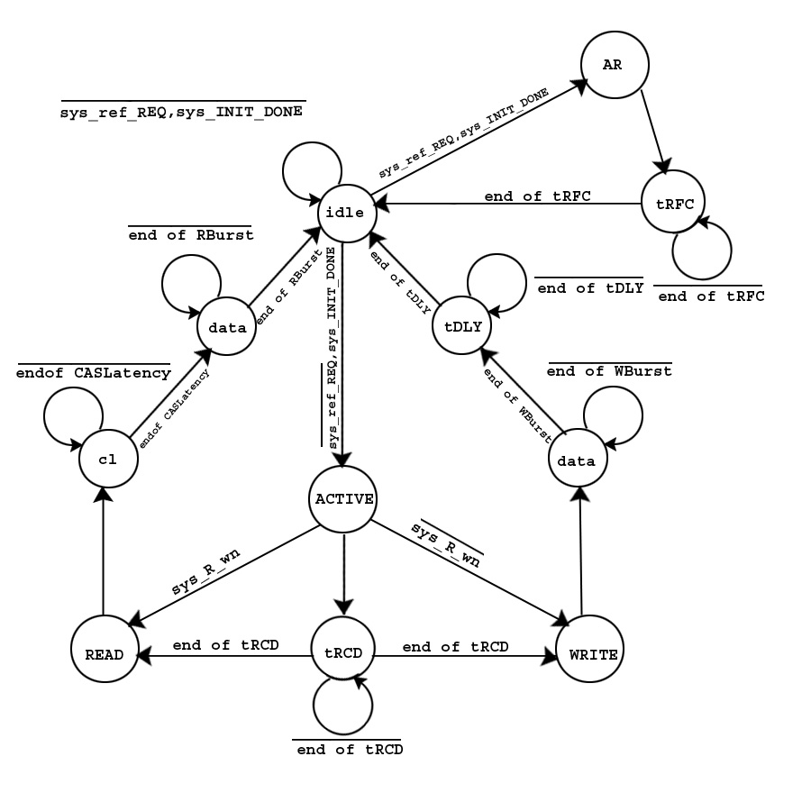
Fig.5.COMMAND_FSM

The SDRAM can be considered as a four by N array of rows. All rows are in the “closed” status after the SDRAM initialization. The rows need to be “opened” before they can be accessed. However, only one row in the same bank can be opened at a time. Since there are four banks, there can be at most four rows opened at the same time. If a row in one bank is currently opened, it must be closed before another row in the same bank can be opened .ACTIVE command is used to open the rows and PRECHARGE (or the AUTO PRECHARGE hidden in the WRITE and READ commands, as used in this design) is used to close the rows. When issuing the commands for opening or closing the rows, both row address and bank address need to be provided.
For sequential access applications and those with page memory management, the proper address assignments and the use of the SDRAM pipeline feature deliver the highest performance SDRAM controller. However, this type of controller design is highly associated with the bus master cycle specification and will not fit the general applications. Therefore, this SDRAM controller design does not implement these custom features to achieve the highest performance through these techniques.
In this design, the ACTIVE command will be issued for each read or write access to open the row. After a tRCD delay is satisfied, READ or WRITE commands will be issued with a high sdr_A [10] to enable the AUTO REFRESH for closing the row after access. So, the clocks required for read/write cycle are fixed and the access can be random over the full address range.
Read or write is determined by the sys_R_Wn status sampled at the rising edge of the clock before tRCD delay is satisfied. If a logic high is sampled, the state machine switches to c_READA. If a logic low is sampled, the state machine switches to c_WRITEA.
For read cycles, the state machine switches from c_READA to c_cl for CAS latency, then switches to c_rdata for transferring data from SDRAM to bus master. The number of clocks the state machine stays in c_rdata state is determined by the burst length. After the data is transferred, it switches back to c_idle.

For write cycles, the state machine switches from c_WRITEA to c_wdata for transferring data from bus master to SDRAM, then switches to c_tDAL. Similar to read, the number of clocks the state machine stays in c_wdata state is determined by the burst length. The time delay tDAL is the sum of WRITE recovery time tWR and the AUTO PRECHARGE timing delay tRP. After the clock rising edge of the last data in the burst sequence, no commands other than NOP can be issued to SDRAM before tDAL is satisfied.
As mentioned in the INIT_FSM section above, the dash lines indicates possible state switching paths when tCK period is larger than timing delay spec.

CHAPTER-3
Commands

3.1. NO OPERATION (NOP)
The NOP is a “No Operation” command to the controller. When detected, the controller performs a NOP in the following clock cycle. A NOP must be issued the following clock cycle after the controller has acknowledged a command. The NOP command has no effect on SDRAM accesses that are already in progress.
The NO OPERATION (NOP) command is used to instruct the selected DDR SDRAM to perform a NOP (CS# is LOW with RAS#, CAS#, and WE# are HIGH). This prevents unwanted commands from being registered during idle or wait states. Operations already in progress are not affected.
3.2. ACTIVE (ACT)
The ACTIVE command is used to open (or activate) a row in a particular bank for a subsequent access, like a read or a write, as shown in Figure 17. The value on the BA0, BA1 inputs selects the bank, and the address provided on inputs A0–A7 selects the row.

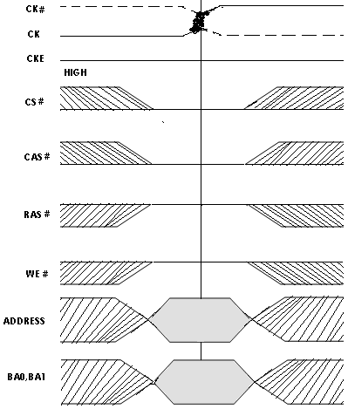

Figure 6: Active command

3.3 READ
The READ command is used to initiate a burst read access to an active row, as shown in Figure 18 on page 42. The value on the BA0, BA1 inputs selects the bank, and the address provided on inputs A0–Ai (where Ai is the most significant column address bit for a given density and configuration, see Table 2 on page 2) selects the starting column location.

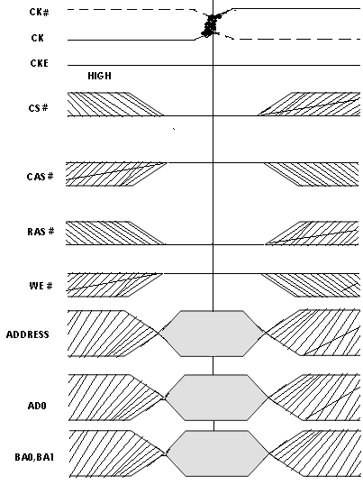

Fig: 7. Read Command

The READ command instructs the controller to perform a burst read with auto-precharge to the SDRAM at the memory address specified by ADDR. The controller will issue an ACTIVATE command to the SDRAM followed by a READ command.
The read burst data will first appear on DATAOUT (RC + CL + 4) clock cycles after the controller has asserted command acknowledge (CMDACK), where CL is the integer portion of the actual CAS Latency(i.e. if CAS Latency is 2.5 then CL = 2).
Because the data interface to the DDR devices is one half the width of the DATAOUT port, the effective burst length of the data from DATAOUT is one half the burst length that the DDR devices are configured for.

During a READA command the user must keep the DM inputs low. The timing for a READ command is shown in Figure . The operation of a READ command is as follows:
- The user asserts READ along with ADDR and DM.
- The controller acknowledges the command by asserting CMDACK.
- Simultaneously with asserting CMDACK the controller starts issuing commands to the SDRAM devices.
- One clock after CMDACK was asserted, the user must assert NOP CMD.
- (RC + CL + 4)clock cycles following assertion of CMDACK by the controller, the controller presents the first read burst value on DATAOUT, with the remainder of the burst following every clock there after.

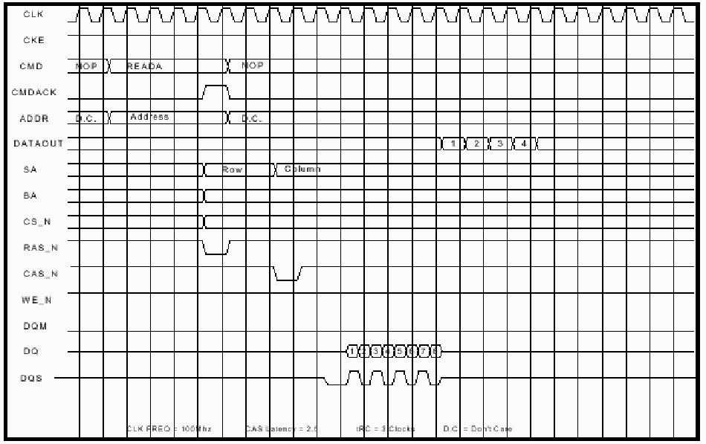
Figure.8 READ Timing Diagram

  - WRITE
The WRITE command is used to initiate a burst write access to an active row as shown in Figure 19. The value on the BA0, BA1 inputs selects the bank, and the address provided on inputs A0–Ai (where Ai is the most significant column address bit for a given density and configuration.) selects the starting column location.
The WRITE command instructs the controller to perform a burst write with auto-precharge to the SDRAM at the memory address specified by ADDR. The controller will issue an ACTIVATE command to the SDRAM followed by a WRITE command. The first data value in the burst sequence must be presented with the WRITE and ADDR address.
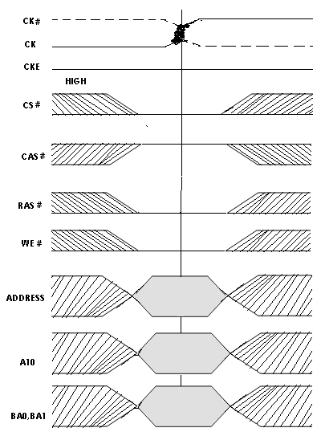

Fig:9. Write Command

The operation of a WRITE command is as follows:
- The user asserts WRITE along with ADDR and the first write data value
On DATAIN and the desired data mask value on DM.
- The controller acknowledges the command by asserting CMDACK.
- Simultaneously with asserting CMDACK the controller starts issuing commands to the SDRAM devices.
- One clock after CMDACK was asserted, the user asserts NOP on CMD.
- tRC-2 following the assertion of CMDACK by the controller, the user clocks data and data mask values into the controller through DATAIN and DM.
The host must start clocking data into the controller tRC-2 clocks after the controller has acknowledged the WRITE command. The controller runs the DQ port to the DDR devices at one half the width and twice the rate of the DATAIN port. These results in burst lengths at the DATAIN port being one half the length that the DDR devices are configured for.
The DM inputs are clock through the controller with the data and sent to the SDRAM devices on the DQM outputs. See a SDRAM data sheet for how to use the DQM lines. The timing for a WRITE command is shown in Figure 10.

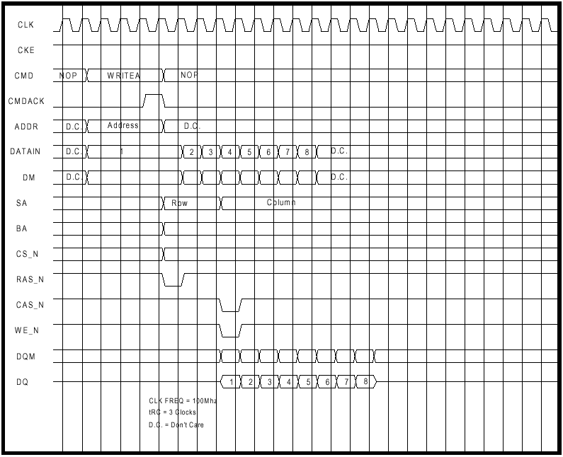
Figure.10. WRITE Timing Diagram

3.5. REFRESH
The REFRESH command instructs the controller to perform an AUTO REFRESH command to the SDRAM. The controller will acknowledge the REFRESH command with CMDACK. A timing diagram of the REFRESH command is shown in Figure.
The operation of a REFRESH command is as follows:
- The user asserts REFRESH on CMD input, the controller acknowledges the command by asserting CMDACK.
- Simultaneously with asserting CMDACK the controller starts issuing
Commands to the SDRAM devices.
- Immediately following the assertion of CMDACK by the controller, the
user asserts NOP on CMD.

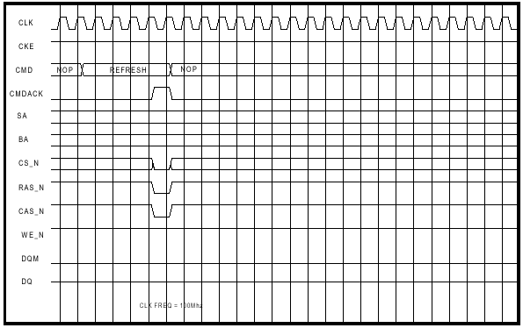

Figure.11 REFRESH Timing Diagram

3.6 PRECHARGE
The PRECHARGE command is used to deactivate the open row in a particular bank or the open row in all banks as shown in Figure 20. The value on the BA0, BA1 inputs selects the bank, and the A10 input selects whether a single bank is precharged or whether all banks are precharged.

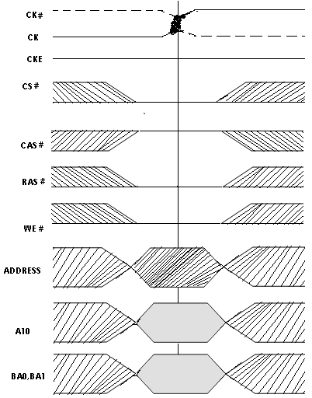

Fig:12.Precharge Command

The PRECHARGE command instructs the controller to perform a PRECHARGE command to the SDRAM. The controller will acknowledge the command with CMDACK. A timing diagram of the PRECHARGE command is shown in Figure.5.
The operation of a PRECHARGE command is as follows:
- The user asserts PRECHARGE on CMD.
- The controller acknowledges the command by asserting CMDACK.
- Simultaneously with asserting CMDACK the controller starts issuing
commands to the SDRAM devices.
- Immediately after the controller asserts CMDACK, the user asserts NOP on CMD.
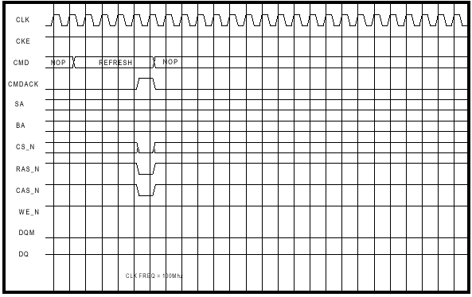
Figure.13. PRECHARGE Timing Diagram

  - LOAD_MODE

The LOAD_MODE command instructs the controller to perform a LOAD MODE REGISTER command to the SDRAM. The value that is to be written into the SDRAM mode register must be present on ADDR [11:0] with the LOAD_MODE command. The value on ADDR [11:0] is mapped directly to the SDRAM pins A11- A0 when the controller issued the LOAD MODE REGISTER to the SDRAM. A timing diagram is shown in Figure.6. DDR devices have an Extended Mode Register that is accessed with the LOAD_MODE command and setting BA[1:0]=01b. Setting BA to 01b is accomplished by setting the appropriate bits in ADDR during a LOAD_MODE command. The mapping of ADDR bits to BA bits is defined in the file PARAMS.
- The user asserts LOAD_MODE on CMD.
- The controller acknowledges the command by asserting CMDACK.
- Simultaneously with asserting CMDACK the controller starts issuing commands to the SDRAM devices.
- One clock after the controller asserts CMDACK, the user asserts NOP on CMD.

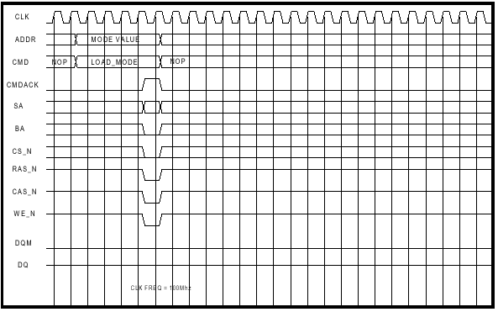
Figure.14 LOAD_MODE Timing Diagram
3.8 LOAD_REG1
The LOAD_REG1 command instructs the controller to load the internal configuration register REG1. The value that is to be written into REG1 must be presented on the ADDR input simultaneously with the assertion of the command LOAD_REG1. The bit assignments for REG1 are shown in Table.
CL is the CAS latency of the SDRAM memory in clock periods and is dependent on the memory device speed grade and clock frequency. Consult the SDRAM data sheet for appropriate settings. CL must be set to the same value as CL for the SDRAM memory devices.
RC is the RAS to CAS delay in clock periods and is dependent on the SDRAM speed grade and clock frequency. The formula is RC= INT (tRC/ clock_period). Where tRC is the value from the SDRAM data sheet and clock_period is the clock period of the clock that the controller and SDRAM will be running off of.
RRD is the Refresh to RAS delay in clock periods. RRD is dependent on the SDRAM speed grade and clock frequency. The formula is RRD= INT (tRRD / clock_period).

Where tRRD is the value from the SDRAM data sheet and clock_period is the clock period of the clock that the controller and SDRAM will be running off of BL is the burst length the SDRAM devices have been configured for divided by two to account for the multiplexed nature of the data bus for the DDR Controller.

Label | ADDR Bits | Description
CL | [1:0] | Cas Latency setting the controller.  00=1.5 01=2.0 10=2.5 11=3.0
RC | [3:2] | RAS to CAS delay in number of clocks.
RRD | [7:4] | REFRESH command duration in clocks.
BL | [12:9] | Burst Length, Valid value are 1, 2, 4.

Table.6 REG Bit Definition
3.9 LOAD_REG2
The LOAD_REG2 command instructs the controller to load the internal configuration register REG2. REG2 is a 16-bit value that represents the period between REFRESH commands that the controller issues. The value is set by the equation int(REF_PERIOD / CLK_PERIOD). For example, if a SDRAM device connected to the controller has a 64ms, 4096 Cycle refresh requirement the device must have a REFRESH command issued to it at least every 64ms/4096 = 15.625 us. If the SDRAM and controller are clocked by a 100 MHz clock then the maximum value of REG2 should be 15.625us / .01us = 1562. The value that is to be written into REG2 must be presented on the ADDR input simultaneously with the assertion of the command LOAD_REG2.
3.10 BURST TERMINATE (BST)
The BURST TERMINATE command is used to truncate READ bursts (with auto precharge disabled). The most recently registered READ command prior to the BURST TERMINATE command will be truncated, as shown in “Operations” . The open page from which the READ burst was terminated remains open.

3.11 AUTO REFRESH
AUTO REFRESH is used during normal operation of the DDR SDRAM and is analogous to CAS#-before-RAS# (CBR) refresh in FPM/EDO DRAMs. This command is non persistent, so it must be issued each time a refresh is required. All banks must be idle before an AUTO REFRESH command is issued.
3.12 SELF REFRESH
The SELF REFRESH command can be used to retain data in the DDR SDRAM, even if the rest of the system is powered down. The SELF REFRESH command is initiated like an AUTO REFRESH command except CKE is disabled (LOW).

Chapter-4

Controller Configuration

The SDRAM devices that are connected to the SDRAM controller must be initialized before they can be accessed. This initialization process set the burst length, CAS latency, burst type, and operation mode for the SDRAM devices. After the SDRAM devices are initialized the SDRAM controller’s configurations registers must be set. The procedure for initializing the SDRAM devices and the Controller is as follows:

4.1 Architecture
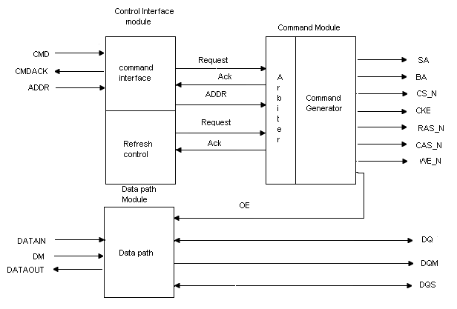
Figure.15 DDR SDRAM Controller Core Diagram

The DDR SDRAM Controller Core consists of four main modules, the SDRAM controller, Control Interface, Command, and Data Path Modules. The DDR SDRAM controller module is the top-level module that instantiates the three lower modules and brings the whole design together. The Control Interface Module accepts commands and related memory addresses from the host, decoding the command and passing the request to the Command module.
The Command Module accepts command and address from the Control Interface Module, generating the proper commands to the SDRAM. The Data Path Module handles the data path operations during WRITEA and READA commands. The top-level module also instantiates two PLL’s that are used in the CLOCK_LOCK and 2X mode to improve I/O timing and to generate a 2X clock.

4.2. Command Module
The Command Module accepts decoded commands from the Control Interface Module, along with refresh requests from the refresh control logic and generates the appropriate commands to the SDRAM. The module contains a simple arbiter that arbitrates between the commands from the host interface and the refresh requests from the refresh control logic. The refresh requests from the refresh control logic have priority over the commands from the host interface. If a command from the host arrives at the same time or during a “hidden” refresh operation, the arbiter holds off the host by not asserting CMDACK until the hidden refresh operation is complete. If a hidden refresh command is received while a host operation is in progress then the hidden refresh is held off until the host operation is complete. A block diagram of the Command Module is shown in Figure.18.

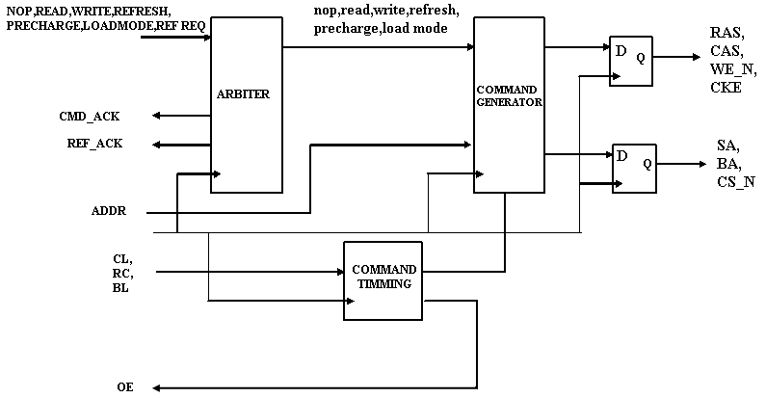
Figure. 16 Command Module Block Diagram

After the arbiter has accepted a command from the host, the command is passed onto the command generator portion of the Command Module. The command Module uses three shift registers to generate the appropriate timing between the commands that are issued to the SDRAM. One shift register is used to control the timing the ACTIVATE command while a second is used to control the positioning of the READA or WRITEA commands. A third is used to time command durations, in order for the arbiter to determine if the last requested operation is complete.
The Command Module also performs the multiplexing of the address (ADDR) to the SDRAM. The row portion of the address is multiplexed out to the SDRAM outputs A[11:0] during the ACTIVATE (RAS) command. The column portion is then multiplexed out to the SDRAM address outputs during a READA (CAS) or WRITEA command. The output signal OE is generated by the Command Module to control tristate buffers in the last stage of the DATAIN path in the Data Path Module. in Mbytes/sec is 1 / (clk period ns * number of clocks per access) * (data path width in Bytes) * (burst length of the access)

Define | Description
DSIZE | Define the size of the DATAIN and DATAOUT ports. DQ is sized to be ½ DSIZE. Possible values are 32.64.96.128
ASIZE | Define the size of the ADDR port.
ROSTART | Define the starting position within ADDR of the group of bits that are to be used for the row address to the SADRAM devices.
ROWSIZE | Define the number of bits to use, starting at ROWSTART within ADDR, for the SDRAM row address.
COPLSTART | Define the starting position within ADDR of the group of bits that are to be used for the column address to the SDRAM devices.
COLSIZE | Define the number of bits to use, starting at COLSTART within ADDR, for the SDRAM column address.
BANKSTART | Define the starting position within ADDR of the group of bits that are to be used for the bank address to the SDRAM devices.
BANKSIZE | Define the number of bits to use, starting at COLSTART within ADDR, for the SDRAM bank address.
Table 7 DDR SDRAM Controller Defines
4.3 Read/Write Cycle
Figure 4 shows the state diagram of CMD_FSM which handles the read, write and refresh of the SDRAM. The CMD_FSM state machine is initialized to c_idle during reset. After reset, CMD_FSM stays in c_idle as long as sys_INIT_DONE is low which indicates the SDRAM initialization sequence is not yet completed.
Once the initialization is done, sys_ADSn and sys_REF_REQ will be sampled at the rising edge of every clock cycle. A logic high sampled on sys_REF_REQ will start a SDRAM refresh cycle. This is described in the following section. If logic low is sampled on both sys_REF_REQ and sys_ADSn, a system read cycle or system write cycle will begin. These system cycles are made up of a sequence of SDRAM commands.
4.4 Refresh Cycle:
Similar to the other DRAMs, memory refresh is required. A SDRAM refresh request is generated by activating sdr_REF_REQ signal of the controller. The sdr_REF_ACK signal will acknowledge the recognition of sdr_REF_REQ and will be active throughout the whole refresh cycle. The sdr_REF_REQ signal must be maintained until the sdr_REF_ACK goes active in order to be recognized as a refresh cycle. Note that no system read/write access cycles are allowed when sdr_REF_ACK is active. All system interface cycles will be ignored during this period. The sdr_REF_REQ signal assertion needs to be removed upon receipt of sdr_REF_ACK acknowledge, otherwise another refresh cycle will again be performed.
Upon receipt of sdr_REF_REQ assertion, the state machine CMD_FSM enters the c_AR state to issue an AUTO REFRESH command to the SDRAM. After tRFC time delay is satisfied, CMD_FSM returns to c_idle.

4.5 Data Path
The data flow design between the SDRAM and the system interface. The module in this reference design interfaces between the SDRAM with 16-bit data bus and the bus master with 64-bit data bus. The user should be able to modify this module to customize to fit his/her system bus requirements.
The size of each bus in Figure shown by the number under the slash across the bus. The grayed components are for read cycles and the white components are for write cycles.

4.6 Timing Diagrams
Figures are the read cycle and write cycle timing diagrams of the reference design with the two CAS latency cycles and the burst length of four. The timing diagrams may be different due to the values of the timing delays tMRD/tRP/tRFC/tRCD/tRCD/tWR, the clock period tCK, the CAS latency and the burst length. The total number of clocks for read and write cycles are decided by these factors. In the example shown in the figures, the read cycle takes 10 clocks and the write cycle takes 9 clocks.
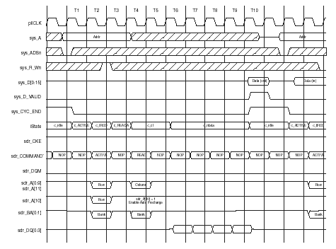

Figure 9: Read Cycle Timing Diagram
The state variable c_State of CMD_FSM is also shown in these figures. Note that the ACTIVE, READ, WRITE commands are asserted one clock after the c_ACTIVE, c_READA, c_WRITEA states respectively.
The values of the region filed with slashes in the system interface input signals of these figures are “don’t care.” For example, signal sys_R_Wn needs to be valid only at the clock before CMD_FSM switches to the c_READA or c_WRITEA states. Depending on the values of tRCD and tCK, this means the signal sys_R_Wn needs to be valid at state c_ACTIVE or the last clock of state c_tRCD
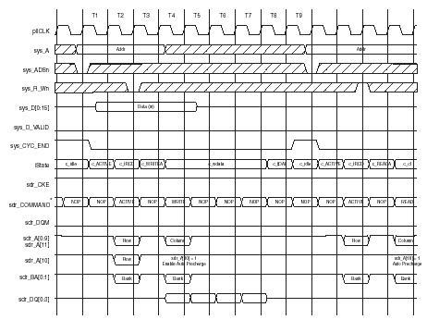

Figure 10: Write Cycle Timing Diagram

CHAPTER-5
SIMULATION RESULTS

WAVE FORMS

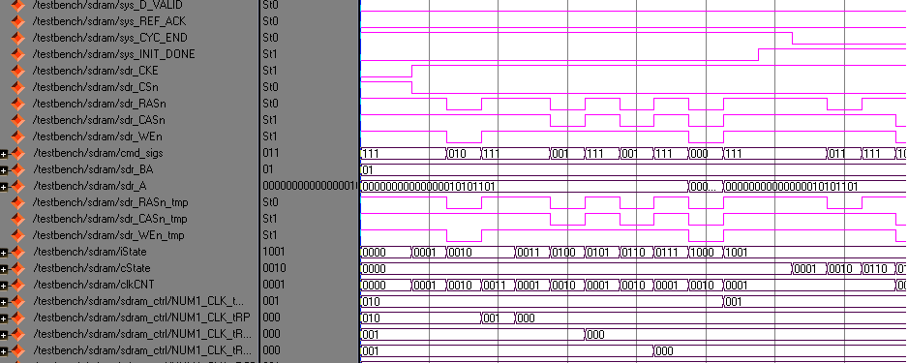

Figure 11: Command and states Diagram

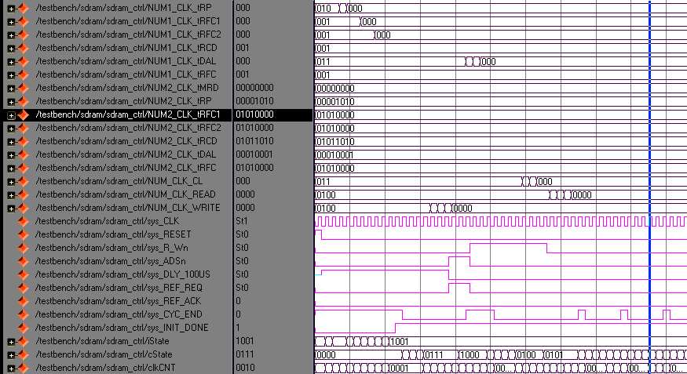

Figure 12: DDR Controller Diagram

HDL Synthesis Report
Macro Statistics
# Counters : 11
3-bit down counter : 8
4-bit down counter : 2
4-bit up counter : 1
# Registers : 39
1-bit register : 35
16-bit register : 1
4-bit register : 2
64-bit register : 1
# Comparators : 1
4-bit comparator greater : 1
# Tristates : 2
16-bit tristate buffer : 1
64-bit tristate buffer : 1
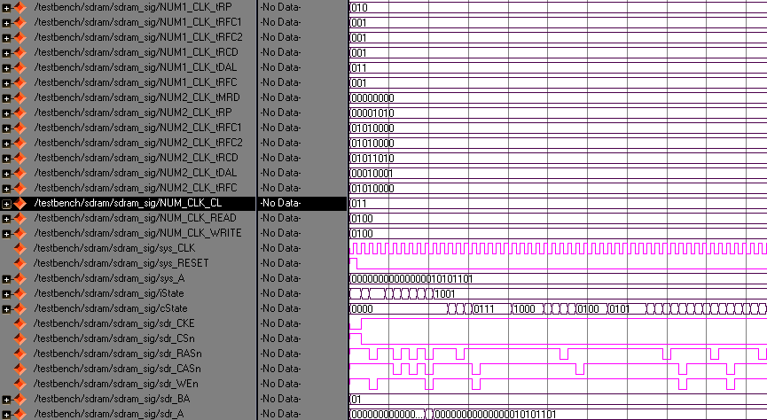

Figure 13: DDR Initialization Diagram

Advanced HDL Synthesis Report
Macro Statistics
# Counters : 11
3-bit down counter : 8
4-bit down counter : 2
4-bit up counter : 1
# Registers : 123
Flip-Flops : 123
# Comparators : 1
4-bit comparator greater : 1

Final Register Report
Macro Statistics
# Registers : 169
Flip-Flops : 169

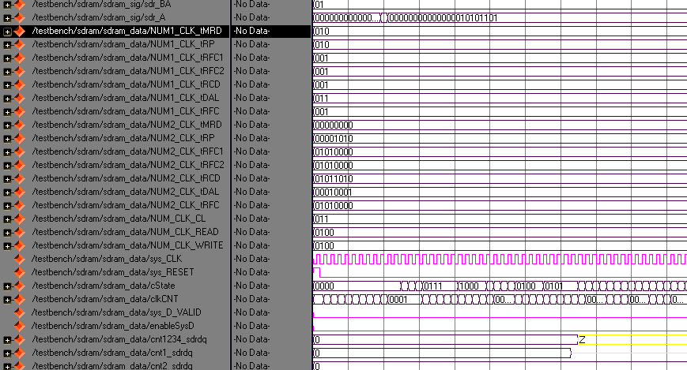

Figure 14 : DDR Signal Generation Diagram

SYNTHESIS REPORT:

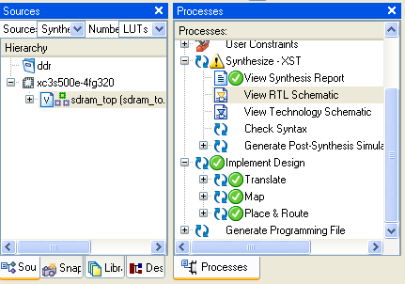
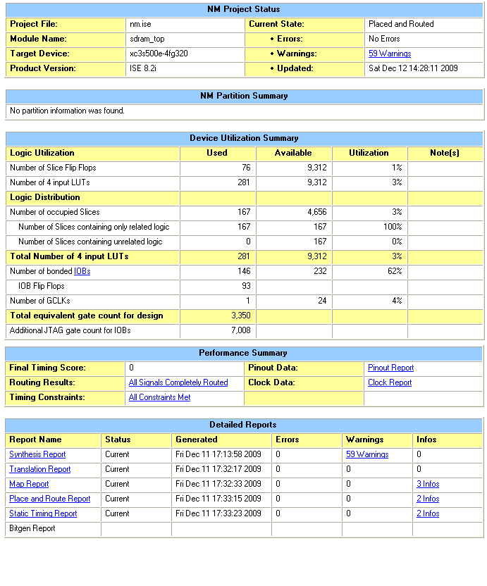

TIMING REPORT

Timing Summary:
---------------
Speed Grade: -4

Minimum period: 8.366ns (Maximum Frequency: 119.531MHz)
Minimum input arrival time before clock: 7.523ns
Maximum output required time after clock: 7.480ns
Maximum combinational path delay: No path found

Final Report

RTL Top Level Output File Name : sdram_top.ngr
Top Level Output File Name : sdram_top
Output Format : NGC
Optimization Goal : Speed
Keep Hierarchy : NO
Design Statistics
# IOs : 146
Cell Usage :
# BELS : 318
# GROUND : 1
# INVERTERS : 12
# LOOK UP TABLES : 100
# LUT2_D : 1
# LUT2_L : 17
# LUT3 : 35
# LUT3_D : 6
# LUT3_L : 2
# LUT4 : 103
# LUT4_D : 11
# LUT4_L : 6
# MULTIPLEXERSF5 : 23
# VCC : 1
# FlipFlops/Latches : 69
# FDC : 42
# FDCE : 64
# FDCP : 25
# FDE : 32
# FDP : 5
# FDR : 1
# Clock Buffers : 1
# BUFGP : 1
# IO Buffers : 145
# IBUF : 28
# IOBUF : 80
# OBUF : 37

Device utilization summary:
Selected Device: 3s500efg320-4

Number of Slices: 161 out of 4656 3%
Number of Slice Flip Flops: 165 out of 9312 1%
Number of 4 input LUTs: 293 out of 9312 3%
Number of IOs: 146
Number of bonded IOBs: 146 out of 232 62%
IOB Flip Flops: 4
Number of GCLKs: 1 out of 24 4%
CHAPTER-6
6.1 Applications
SDRAMs have traditionally been used in personal computers (PCs). Greatly increased performance of PCs has resulted in the need for faster, more efficient, larger and cheaper memories. To meet these needs, DDR SDRAMs were introduced as a cost-effective path for upgrading data bandwidth to memory. They have fast become the memory of choice in PC and server markets.
This drop in price has not gone un-noticed in the networking market. Ever increasing end-performance requirements in this market have resulted in greatly increased data bandwidths, which in turn resulted in the need for faster memories. Memory requirements for networking applications fall into several categories, with DRAMs being primarily used for packet buffer memory (where large amounts of packet memory are required to store entire packets while network processors process the packet headers).
- Image sensing & signal processing
- Scientific imaging & spectroscopy (Andor Technology)
- Detection of low light levels (near infra-red → X-ray)
- Deep space astronomy low light assay imaging on biochip arrays
- Surveillance & military imaging
- Video imaging in bright daylight to overcast starlight
- Used in digital cameras, optical scanners and video cameras as light-sensing devices.
6.2 Advantages
DDR SDRAM devices are low-cost, high-density storage resources that are widely available from many memory vendors. This reference design has been developed using DDR400 SDRAM components.
CHAPTER-7
CONCLUSIONS
7.1 Summary
The similarities between SDR and DDR SDRAM provide the DRAM manufacturer cost advantages and assure high production yields. These similarities also help the designer to better understand DDR and allow the most optimal design techniques from previous designs to be incorporated into the new DDR platforms. Although the addressing schemes, layout requirements, and device configurations are much the same for DDR, the performance gains are remarkable. For example, the power consumption for DDR is significantly less than for a comparable SDR device, yet peak transfer rates can exceed 2.1 GB/s for a standard x64 DDR.
Double Data Rate (DDR) Synchronous Dynamic Random Access Memory (SDRAM) is quickly becoming the memory of choice mainly because of its ability to double the throughput when compared to conventional Single Data Rate (SDR) SDRAM. As processors gain speed, memory modules also need to support them so that the overall system performance is maintained. Several manufacturers make DDR SDRAM, but they all follow the same standard interface. The DDR SDRAM Controller Intellectual Property (IP) provided by Quick Logic has a simplified and easy-to-use user interface.
Traditional single data rate (SDR) SDRAM architectures are performance-limited in their interfaces; therefore, DDR SDRAMs were introduced as an enhancement. While most of the addressing and command control interface is identical, the fundamental difference is in the data interface. The DDR SDRAM architecture employs a 2n-prefetch architecture, where the internal data bus is twice the width of the external data bus. A single read or write cycle involves a single 2n-bit wide, one-clock-cycle data transfer at the core, and two corresponding n-bit wide, one-half-clock-cycle data transfers at the I/O. Thus, this enables high-speed operation as the internal column accesses are half the frequency of the external data transfer rate.

DDR SDRAM is a volatile and complex memory device. When the power is removed, all contents and operating configurations are lost. Each time the memory is powered up, the device requires a defined procedure to initialize the internal state machines and to configure the various user-defined operating parameters.
This project concentrates on the flow for the initialization sequence and the con-figurable device parameters.
7.2 Conclusion
Double Data Rate (DDR) Synchronous Dynamic Random Access Memory (SDRAM) is quickly becoming the memory of choice mainly because of its ability to double the throughput when compared to conventional Single Data Rate (SDR) SDRAM. As processors gain speed, memory modules also need to support them so that the overall system performance is maintained. Several manufacturers make DDR SDRAM, but they all follow the same standard interface. The DDR SDRAM Controller Intellectual Property (IP) provided by Quick Logic has a simplified and easy-to-use user interface.
7.3 Limitations
This DDR2 SDRAM memory interface has a 72-bit data width. The data bus must be placed on either the left or right side banks in the FPGA; the data bus can not be split. If sufficient pins are not available in the FPGA, the data width must be reduced. Address and control signals can use either the same side as the data bus, or any other bank. Like DDR SDRAM memory, DDR2 SDRAM memory is source-synchronous and has a double- data-rate interface. It performs data transfers on both edges of a clock cycle. The advancements of DDR2 SDRAM memories are largely the result of changes in DRAM architecture and signaling, as well as additions to the mode register for lower power and improved command and data bandwidth.

7.4 FUTURE ENHANCEMENT

7.4.1 DDR-II
A new version of DDR II RAM is scheduled. Using another technique, it should be possible to double the performance. It's been proven that adding more memory to a computer system increases its performance. If there isn't enough room in memory for all the information the CPU needs, the computer has to set up what's known as a virtual memory file. In so doing, the CPU reserves space on the hard disk to simulate additional RAM. This process, referred to as "swapping", slows the system down. In an average computer, it takes the CPU approximately 200ns (nanoseconds) to access RAM compared to 12,000,000ns to access the hard drive. To put this into perspective, this is equivalent to what's normally a 3 1/2 minute task taking 4 1/2 months to complete.

8. REFERENCES

1. W.F. Jones, M. Running, L. Draughn, and J. Reed,“Advanced Hardware Architecture for On-line Data Acquisition in Clinical 3-D PET _smart DRAM PCI Card for 14M Event_sec Histogramming across Terabytes of DRAM”,Nuclear Science Symposium Conference Record, October2004, vol. 6, pp. 3663-3667.

2. Burchardt, A., Hekstra-Nowacka, E., and Chauhan, A.,“A Real-time Streaming Memory Controller”, Design, Automation and Test in Europe 2005 Proceedings, 2005, vol.3, pp. 20-25.
3. Heithecker, S. and Ernst, R., “Traffic Shaping for AnFPGA Based SDRAM Controller with Complex QoSRequirements”, Design Automation Conference 2005,June 2005, pp. 575-578.
4. ANALOG DEVICES, AD9480 datasheet, Rev. A, 2004, 7.
5. ALTERA, DDR SDRAM Controller White Paper, Ver1.1, 2002, 8.

6. Guo Li, Zhang Ying, Li Ning, and Guo Yang, “TheFeature of DDR SDRAM and the Implementation of DDR SDRAM Controllers via VHDL”,The Journal of ChinaUniversities of Posts and Telecommunications, 2002, vol.9,no. 1, pp. 61-65

APPENDIX
VERILOG HDL

Overview
Hardware description languages, such as Verilog, differ from software programming languages because they include ways of describing the propagation of time and signal dependencies (sensitivity). There are two assignment operators, a blocking assignment (=), and a non-blocking (<=) assignment. The non-blocking assignment allows designers to describe a state-machine update without needing to declare and use temporary storage variables. Since these concepts are part of the Verilog language semantics, designers could quickly write descriptions of large circuits, in a relatively compact and concise form. At the time of Verilog introduction (1984), Verilog represented a tremendous productivity improvement for circuit designers who were already using graphical schematic-capture, and specially-written software programs to document and simulate electronic circuits.
The designers of Verilog wanted a language with syntax similar to the C programming language, which was already widely used in engineering software development. Verilog is case-sensitive, has a basic preprocessor (though less sophisticated than ANSI C/C++), and equivalent control flow keywords (if/else, for, while, case, etc.), and compatible language operators precedence. Syntactic differences include variable declaration (Verilog requires bit-widths on net/reg types), demarcation of procedural-blocks (begin/end instead of curly braces {}), and many other minor differences.
A Verilog design consists of a hierarchy of modules. Modules encapsulate design hierarchy, and communicate with other modules through a set of declared input, output, and bidirectional ports. Internally, a module can contain any combination of the following: net/variable declarations concurrent and sequential statement blocks and instances of other modules. Sequential statements are placed inside a begin/end and executed in sequential order within the block. But the blocks themselves are executed concurrently, qualifying Verilog as a Dataflow language.
Verilog concept of 'wire' consists of both signal values (4-state: "1, 0, floating, undefined"), and strengths (strong, weak, etc.) This system allows abstract modeling of shared signal-lines, where multiple sources drive a common net. When a wire has multiple drivers, the wire's (readable) value is resolved by a function of the source drivers and their strengths.
A subset of statements in the Verilog language is synthesizable. Verilog modules that conform to a synthesizable coding-style, known as RTL (register transfer level), can be physically realized by synthesis software. Synthesis-software algorithmically transforms the (abstract) Verilog source into a net list, a logically-equivalent description consisting only of elementary logic primitives (AND, OR, NOT, flip-flops, etc.) that are available in a specific VLSI technology. Further manipulations to the net list ultimately lead to a circuit fabrication blueprint (such as a photo mask-set for an ASIC, or a bit stream-file for an FPGA).

History, Beginning
Verilog was invented by Phil Moorby and Prabhu Goel during the winter of 1983/1984 at Automated Integrated Design Systems (later renamed to Gateway Design Automation in 1985) as a hardware modeling language. Gateway Design Automation was later purchased by Cadence Design Systems in 1990. Cadence now has full proprietary rights to Gateway's Verilog and the Verilog-XL simulator logic simulators.

Verilog-95
With the increasing success of VHDL at the time, Cadence decided to make the language available for open standardization. Cadence transferred Verilog into the public domain under the Open Verilog International (OVI) (now known as Accellera) organization. Verilog was later submitted to IEEE and became IEEE Standard 1364-1995, commonly referred to as Verilog-95.
In the same time frame Cadence initiated the creation of Verilog-A to put standards support behind its analog simulator Spectre. Verilog-A was never intended to be a standalone language and is a subset of Verilog-AMS which encompassed Verilog-95.

Verilog 2001
Extensions to Verilog-95 were submitted back to IEEE to cover the deficiencies that users had found in the original Verilog standard. These extensions became IEEE Standard 1364-2001 known as Verilog-2001.
Verilog-2001 is a significant upgrade from Verilog-95. First, it adds explicit support for (2's complement) signed nets and variables. Previously, code authors had to perform signed-operations using awkward bit-level manipulations (for example, the carry-out bit of a simple 8-bit addition required an explicit description of the boolean-algebra to determine its correct value.) The same function under Verilog-2001 can be more succinctly described by one of the built-in operators: +, -, /, *, >>>. A generate/end generate construct (similar to VHDL's generate/end generate) allows Verilog-2001 to control instance and statement instantiation through normal decision-operators (case/if/else). Using generate/end generate, Verilog-2001 can instantiate an array of instances, with control over the connectivity of the individual instances. File I/O has been improved by several new system-tasks. And finally, a few syntax additions were introduced to improve code-readability (eg. always @*, named-parameter override, C-style function/task/module header declaration.) Verilog-2001 is the dominant flavor of Verilog supported by the majority of commercial EDA software packages.

Verilog 2005
Not to be confused with SystemVerilog, Verilog 2005 (IEEE Standard 1364-2005) consists of minor corrections, spec clarifications, and a few new language features (such as the uwire keyword.) A separate part of the Verilog standard, Verilog-AMS, attempts to integrate analog and mixed signal modelling with traditional Verilog.
Design Styles
Verilog, like any other hardware description language, permits a design in either Bottom-up or Top-down methodology.

Bottom-Up Design
The traditional method of electronic design is bottom-up. Each design is performed at the gate-level using the standard gates (refer to the Digital Section for more details). With the increasing complexity of new designs this approach is nearly impossible to maintain. New systems consist of ASIC or microprocessors with a complexity of thousands of transistors.
These traditional bottom-up designs have to give way to new structural, hierarchical design methods. Without these new practices it would be impossible to handle the new complexity.
Top-Down Design
The desired design-style of all designers is the top-down one. A real top-down design allows early testing, easy change of different technologies, a structured system design and offers many other advantages. But it is very difficult to follow a pure top-down design. Due to this fact most designs are a mix of both methods, implementing some key elements of both design styles.
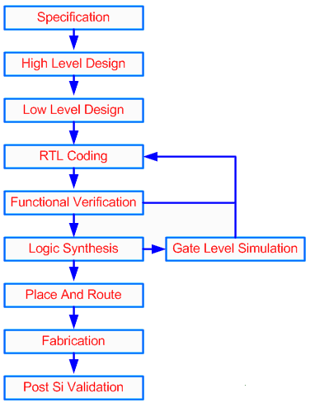
Figure shows a Top-Down design approach.
Verilog Abstraction Levels
Verilog supports designing at many different levels of abstraction. Three of them are very important:
- Behavioral level
- Register-Transfer Level
- Gate Level
Behavioral level
This level describes a system by concurrent algorithms (Behavioral). Each algorithm itself is sequential, that means it consists of a set of instructions that are executed one after the other. Functions, Tasks and Always blocks are the main elements. There is no regard to the structural realization of the design.
Register-Transfer Level
Designs using the Register-Transfer Level specify the characteristics of a circuit by operations and the transfer of data between the registers. An explicit clock is used. RTL design contains exact timing bounds: operations are scheduled to occur at certain times. Modern RTL code definition is "Any code that is synthesizable is called RTL code".
Gate Level
Within the logic level the characteristics of a system are described by logical links and their timing properties. All signals are discrete signals. They can only have definite logical values (`0', `1', `X', `Z`). The usable operations are predefined logic primitives (AND, OR, NOT etc gates). Using gate level modeling might not be a good idea for any level of logic design. Gate level code is generated by tools like synthesis tools and this net list is used for gate level simulation and for backend.
About Verilog HDL
Digital systems are highly complex. At their most detail level, they may consist of millions of elements like transistors or logic gates. Therefore, for large digital systems, gate level design is dead. To avoid that, Verilog HDL was introduced.
Verilog HDL is a Hardware Description Language (HDL). It is a language used to describe a digital system, which may be a computer or a component of a computer. One may describe a digital system at several levels. For example, an HDL might describe the layout of the wires, resistors and transistors on an Integrated Circuit (IC) chip, i.e. the switch level. Or, it might describe the logical gates and flip-flops in a digital system, i.e. the gate level. An even higher level describes the registers and the transfers of vectors of information between registers. This is called the Register Transfer Level (RTL). Verilog supports all of these levels. It is very much like the C language.

Salient Features of Verilog:

- Primitive logic gates such as AND, OR and NAND gates are built-in into this language.
- Flexibility of creating a user-defined primitive (UDP). Such a primitive could either be a combinational logic primitive or a sequential logic primitive.
- Switch-level modeling primitive gates, such as PMOS and NMOS are also built-in into this language.
- Explicit language constructs are provided for specifying pin-to-pin delays, path delays and timing checks of a delay.
- A design can be modeled in three different styles or in a mixed style. These styles are behavioral style modeled using continuous assignments, style-modeled using gate and module instantiations.
- There are two data types in verilog HDL, the net data type and register data type. The net type represents a physical connection between structural elements while a register type represents an abstract data storage element.
- A design can be of arbitrary size; the language does not impose a limit.
- Verilog HDL is non-proprietary and is an IEEE standard.
- It is both human and machine readable. Thus it can be used as an exchange
anguage between tools and designers.
- The capability of the Verilog HDL language can be further extended by using the programming language interface (PLI) mechanism. PLI is a collection of routines that allow foreign functions to access information within a verilog module and allows for designer interaction with the simulator.
- At the behavioral-level, Verilog HDL can be used to describe a design not only at the RTL-level, but also at the architectural-level and its algorithmic-level behavior.
- At the structural-level, gate and module instantiations can be used.
- Verilog HDL also has built-in logic functions such as & (bit wise AND) | (bit wise OR).
- Notion of concurrency and time can be explicitly modeled.
- Powerful file read and write capabilities are provided
- Verilog HDL can be used to perform response monitoring of the design under test, that is, the values of a design under test can be monitored and displayed. These values can also be compared with expected values, and in case of a mismatch, a report message can be printed.
- The language is non-deterministic under certain situations, that is, a model may produce different results on different simulators; for example, the ordering of events on an event queue is not defined by the standard.

